

**Sri Lanka Institute of Information Technology**

**ESBPII 2016 - Assessment 1**

[**AWS INSTANCES SUMMAR**](http://courseweb.sliit.lk/mod/assign/view.php?id=40049)**Y**

**IT13079482**

**Sampath I.D.C**

Get the Amazon Windows Instance.

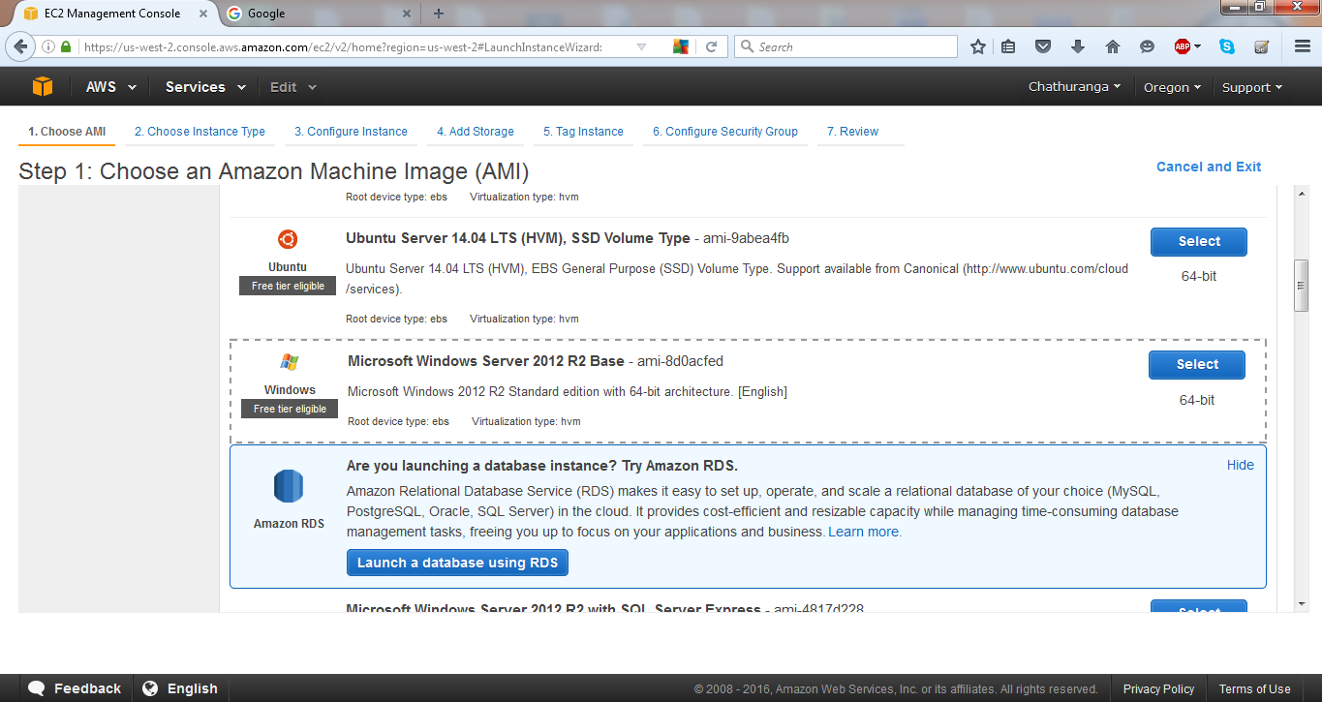

Select t2.micro as the instance type. Then click on the configure instance details button.

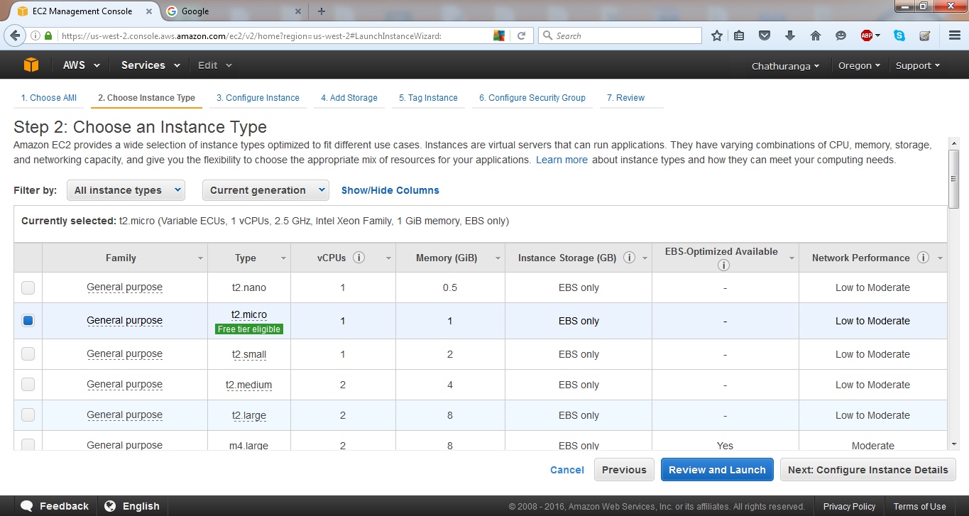

Click on Next: Add storage.

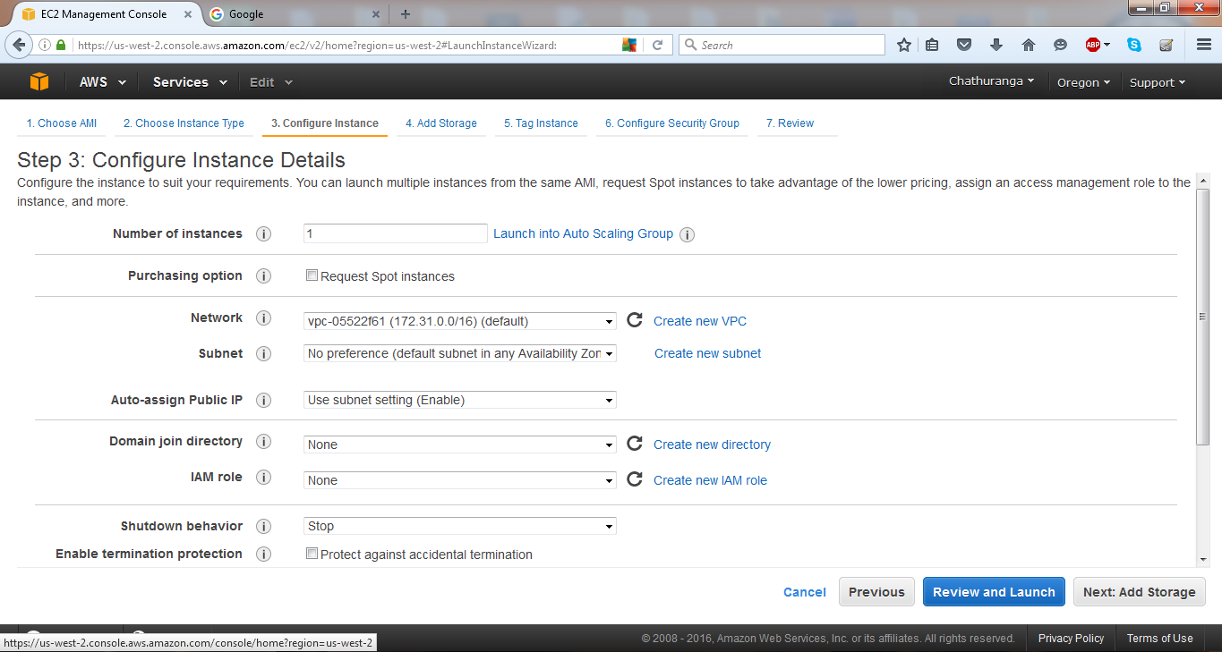

Keep the storage size as it is. Then click on Next: Tag instance button.

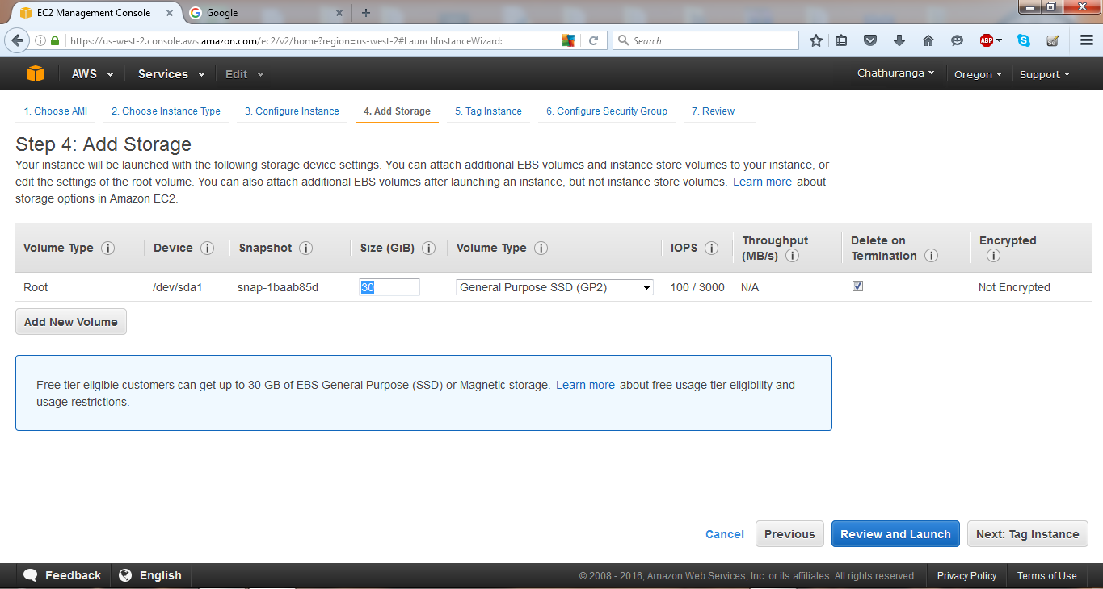

Click on Review and Launch button.

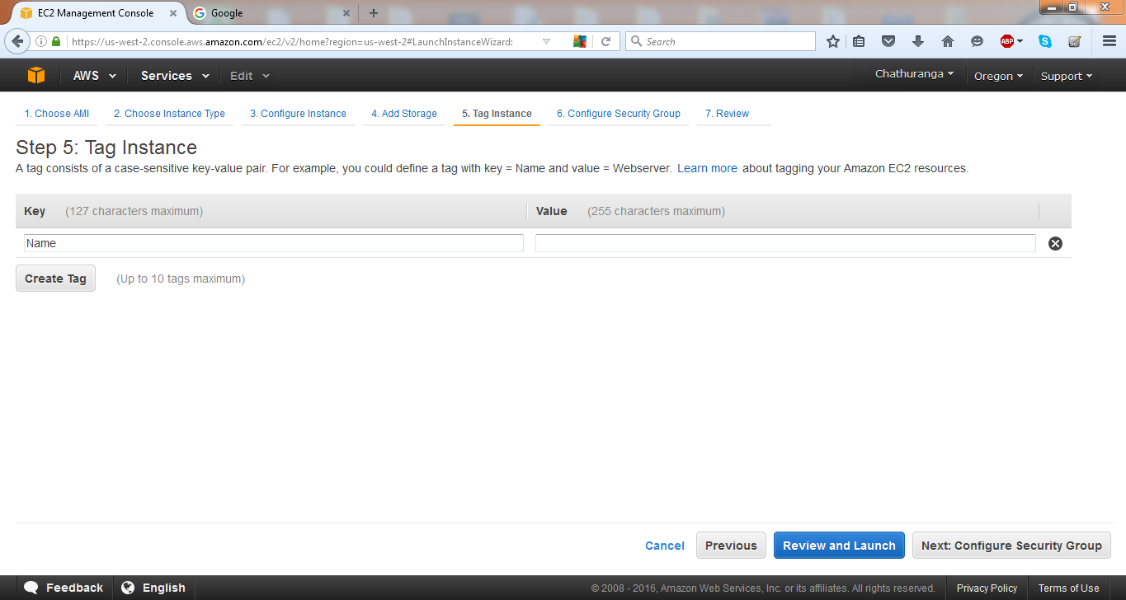

Click on the Launch button.

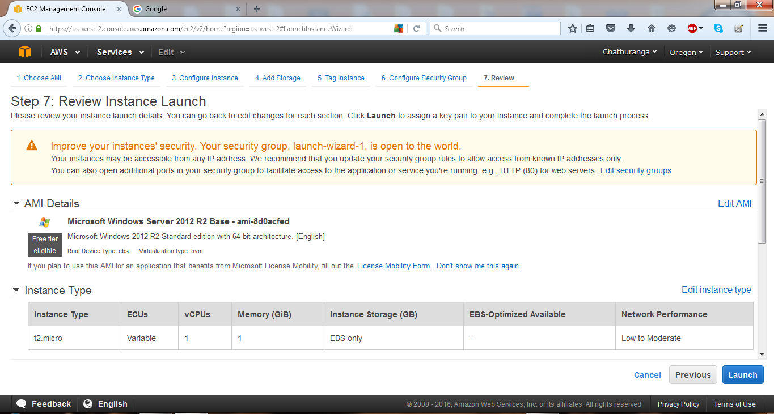

Create a new key pair and download the key pair. Then launch the instance.

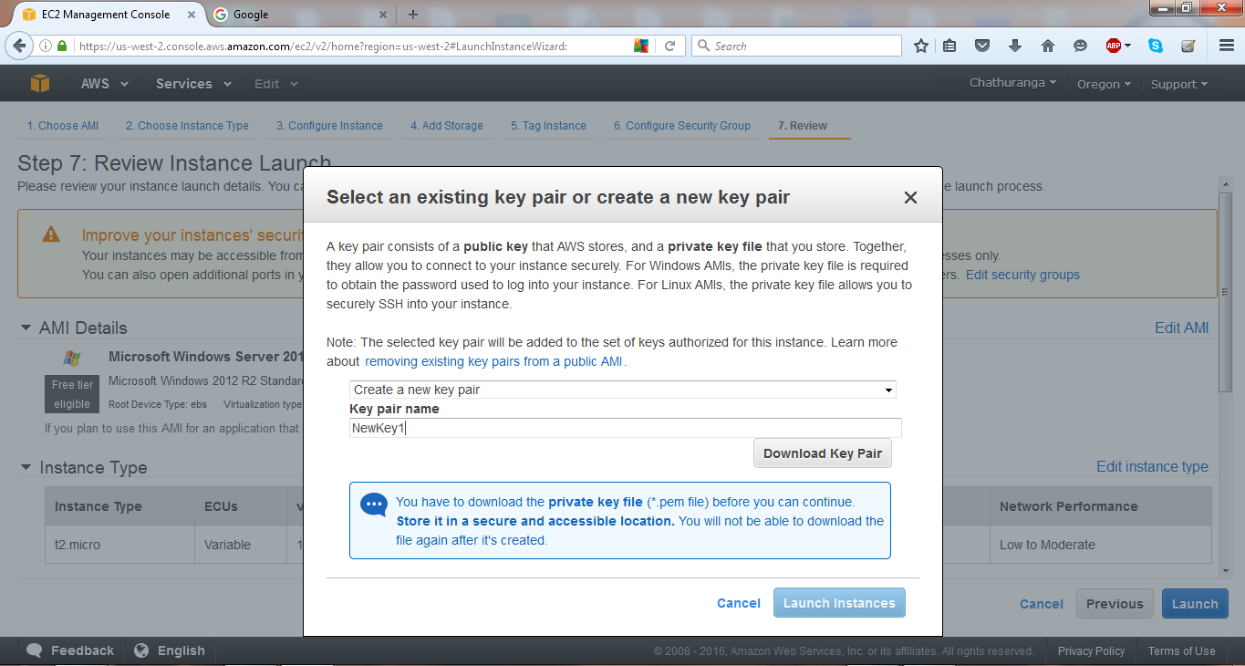

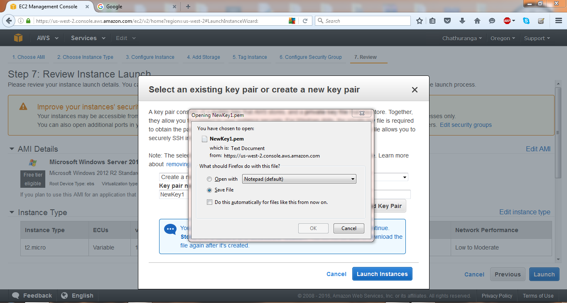

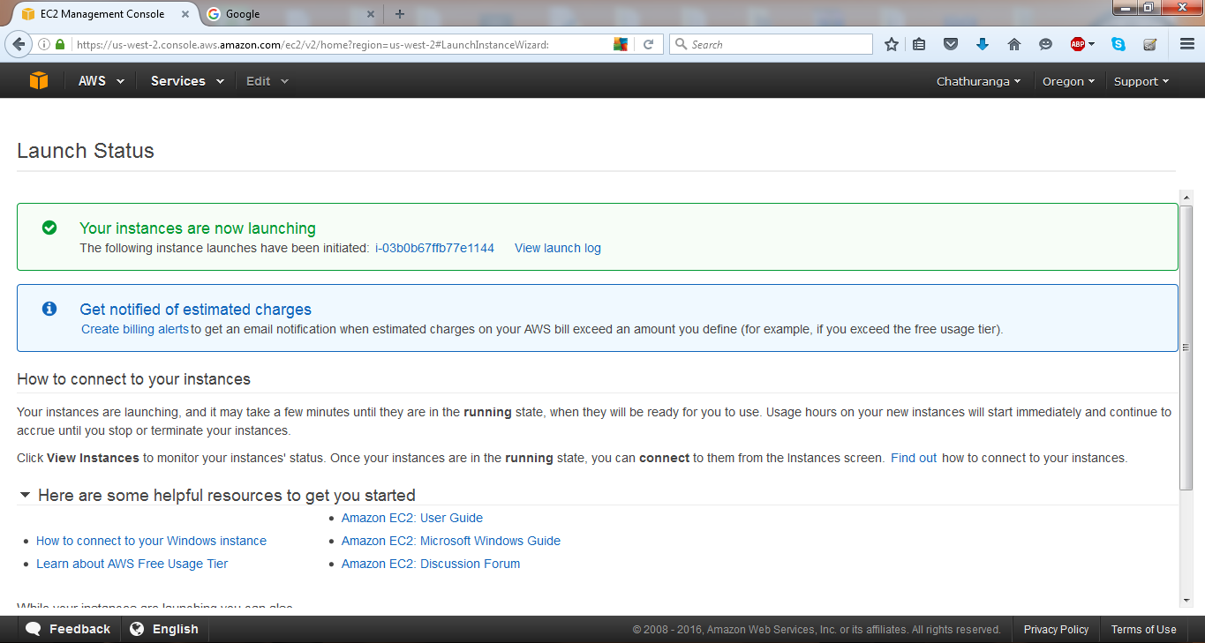

You get the instance details.

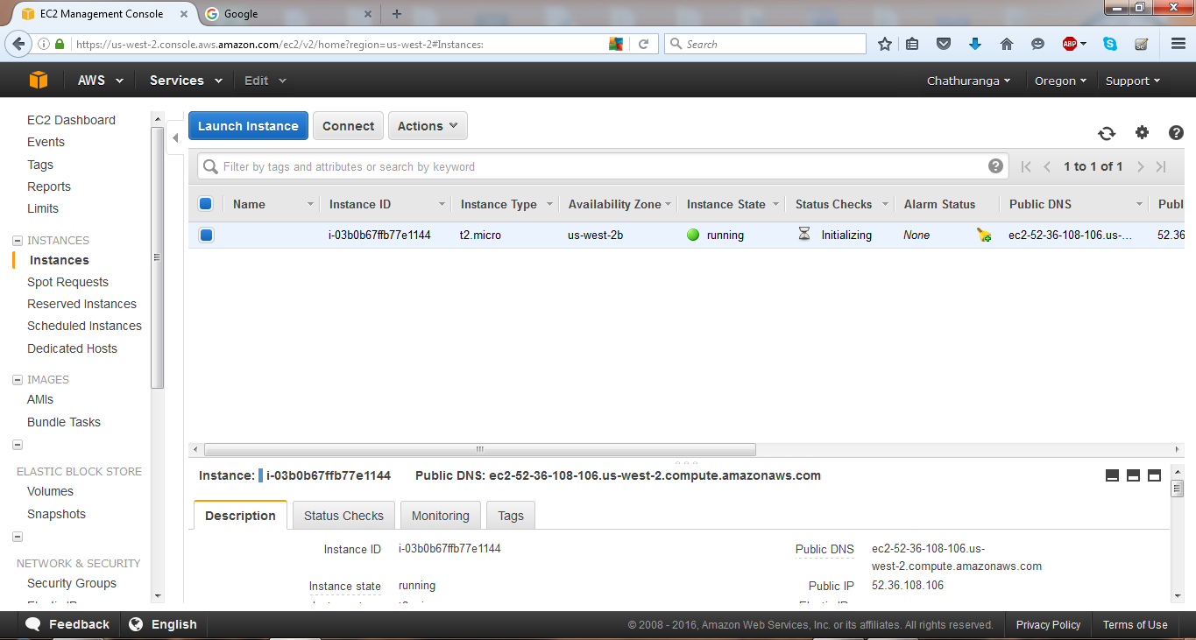

Click on the Connect button to connect to the instance.

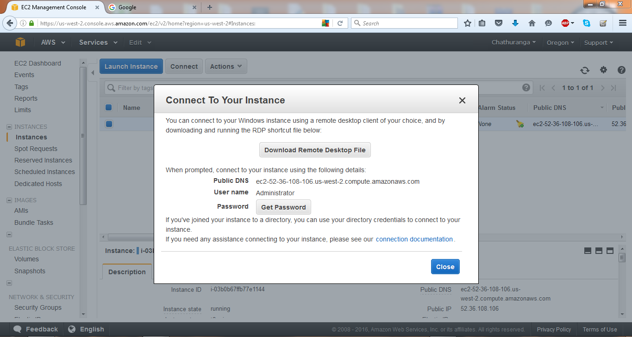

After click on the Get Password button, you will get an interface.

Then click get password and select the downloaded .pem file.

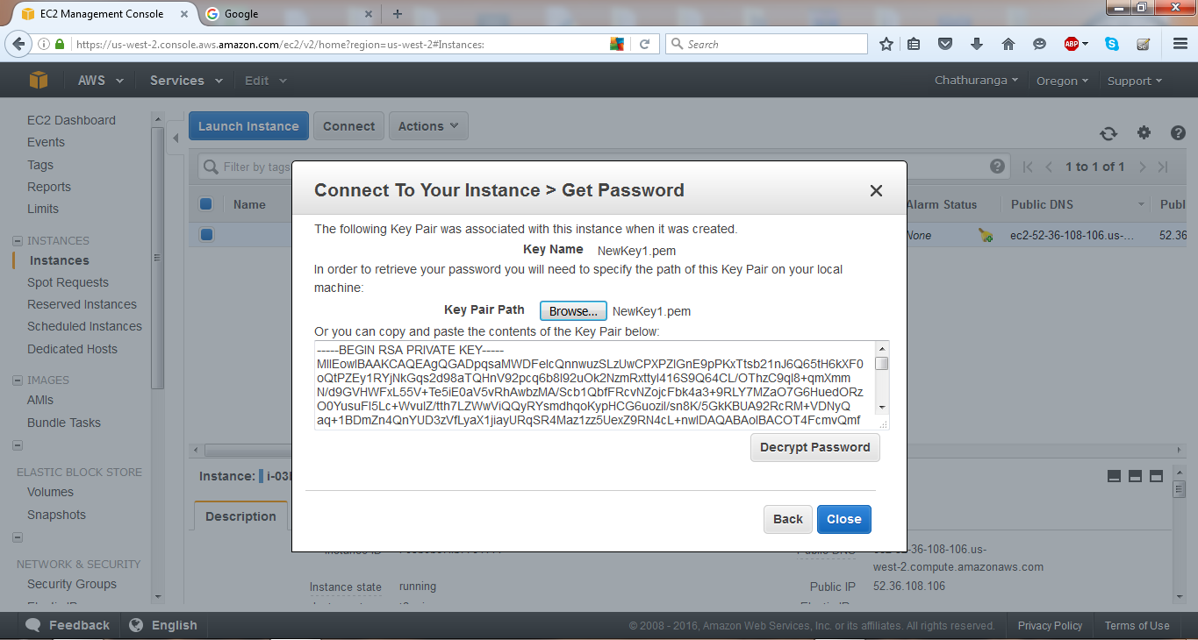

Decrypt the password. You will get the decrypted password.

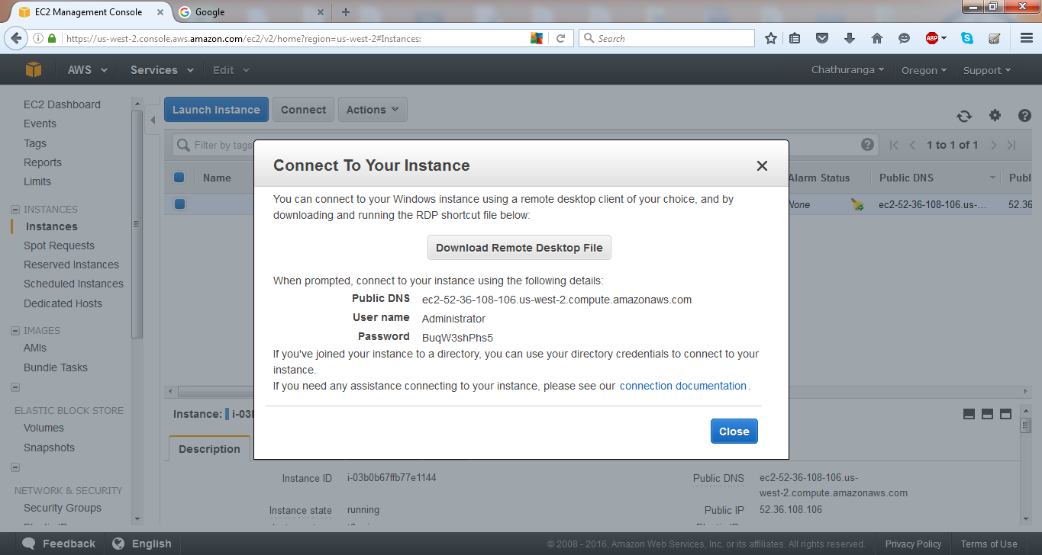

Get the Remote Desktop Connection.

Give the public IP as the remote computer IP. Then click on the Connect button.

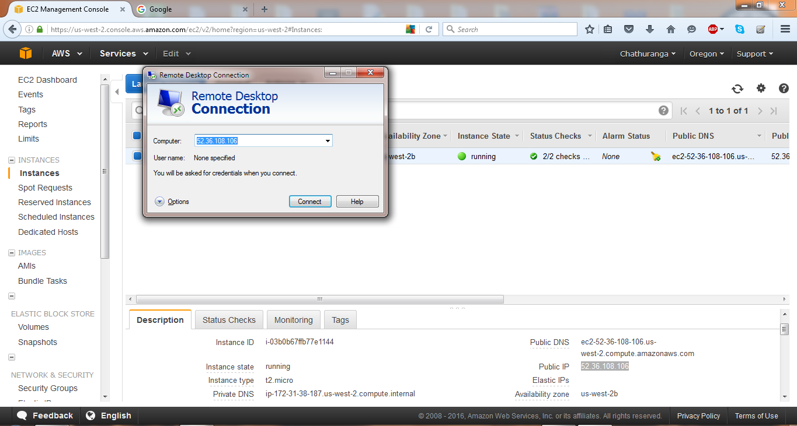

Enter the credentials. Username- Administrator, Password- the decrypted password.

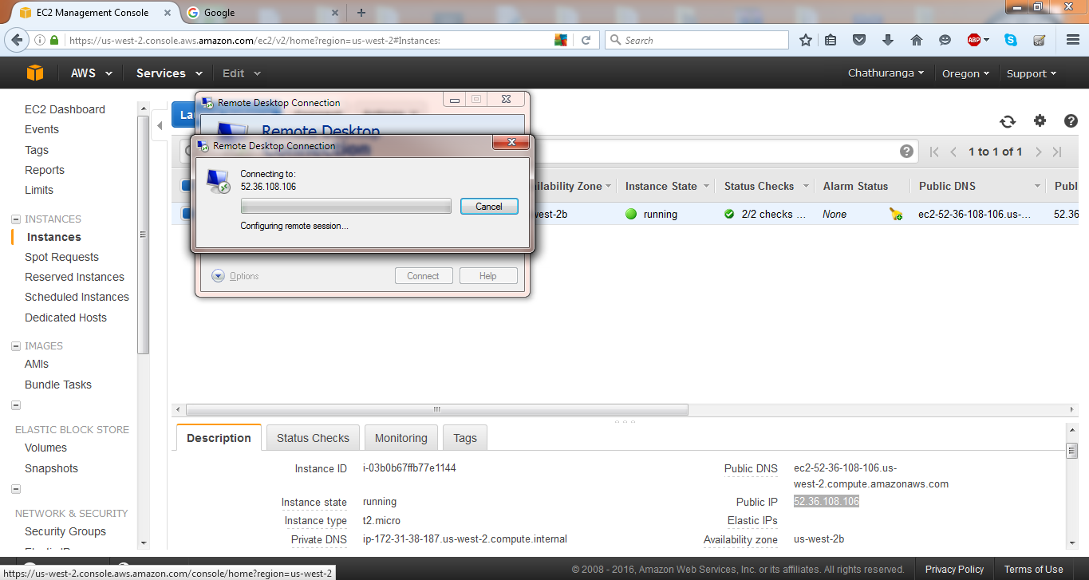

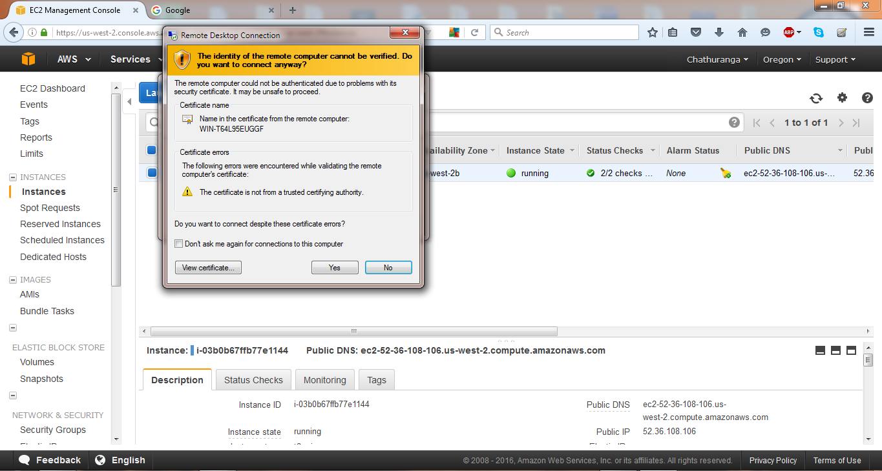

This Windows instance will appear.

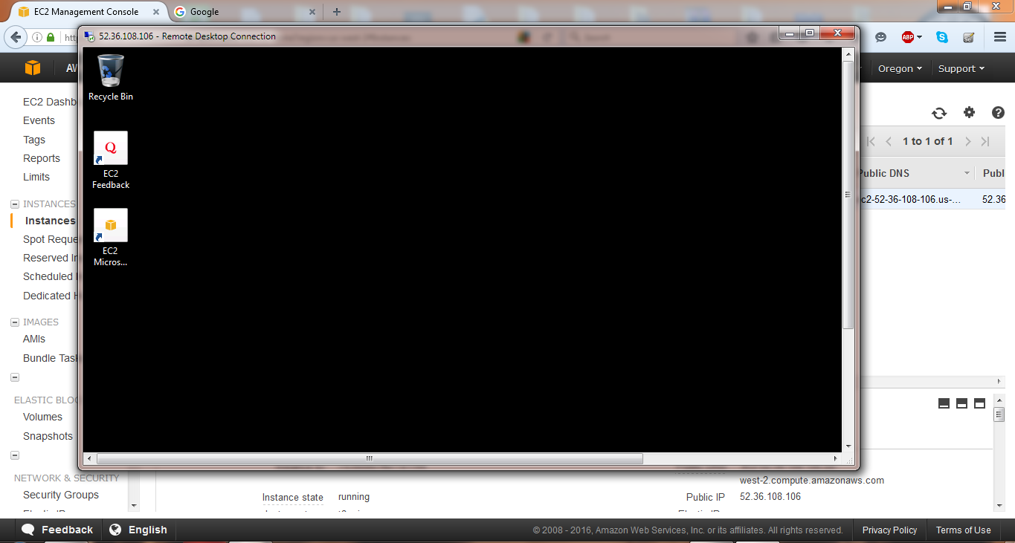

Terminate the windows instance.

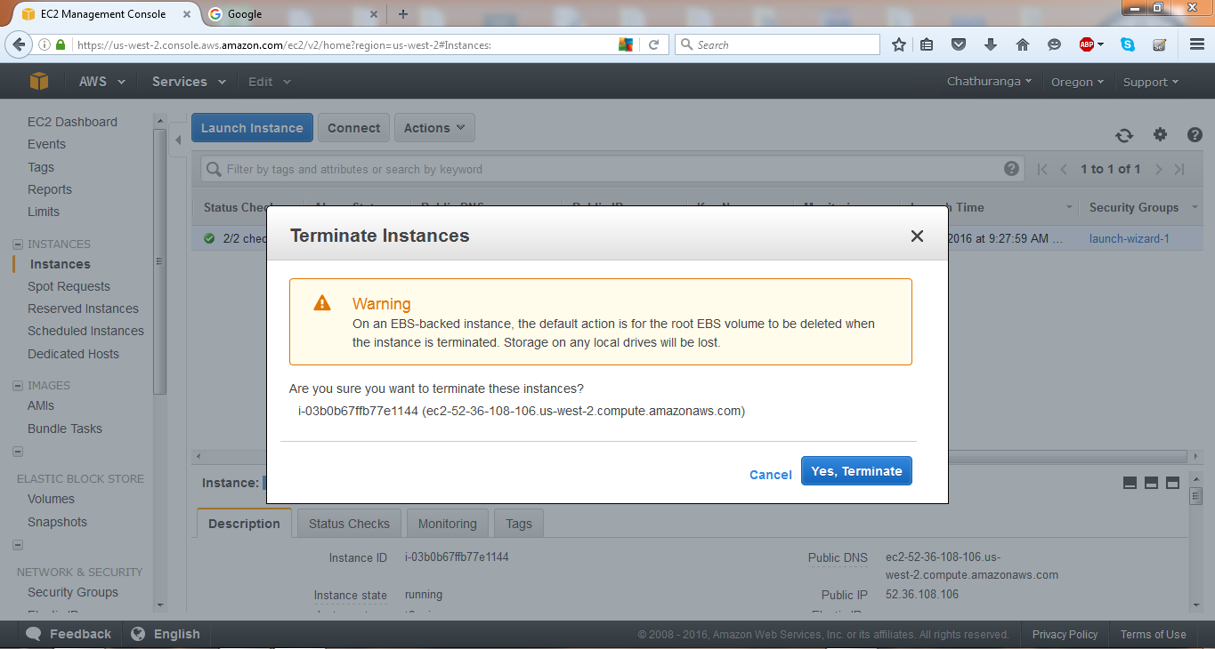

Get the Amazon Linux Instance.

Launch the instance.

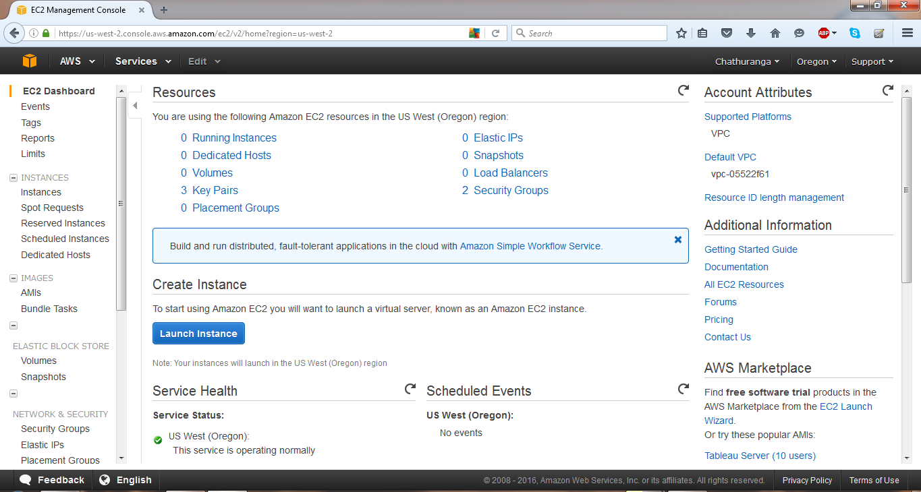

Select Amazon Linux AMI or Red Hat Enterprise Linux.

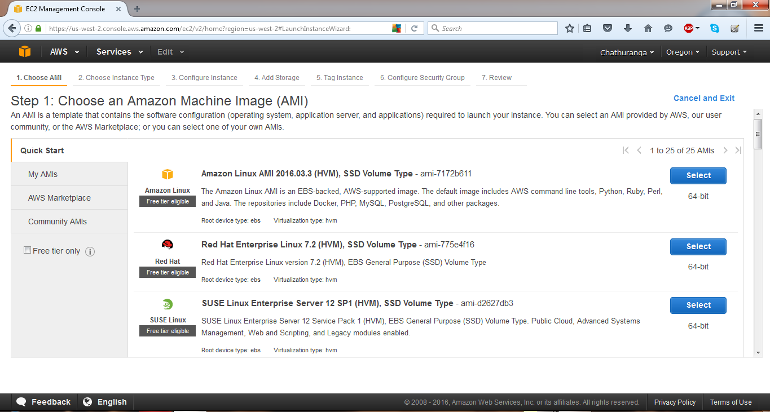

Select t2.micro as the instance type. And click on the configure instance details button.

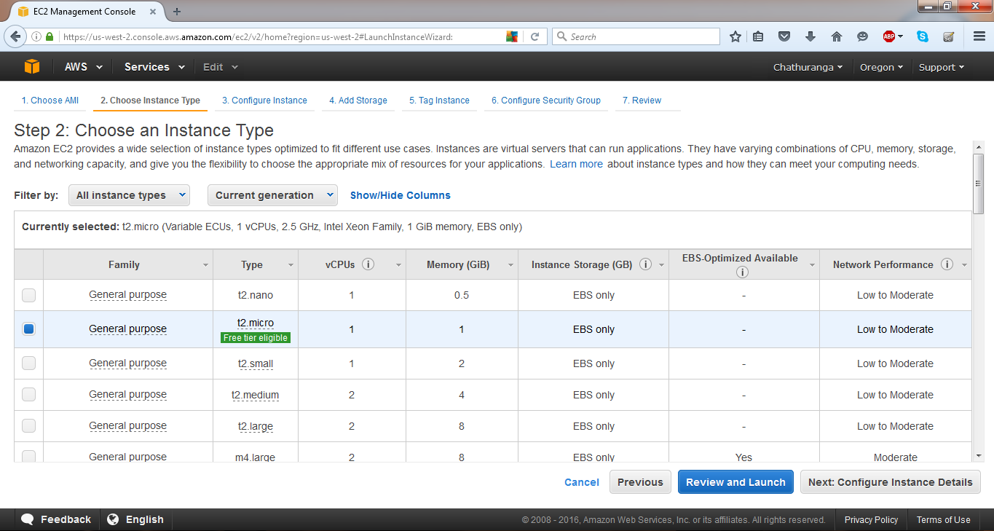

Click on Next: Add storage.

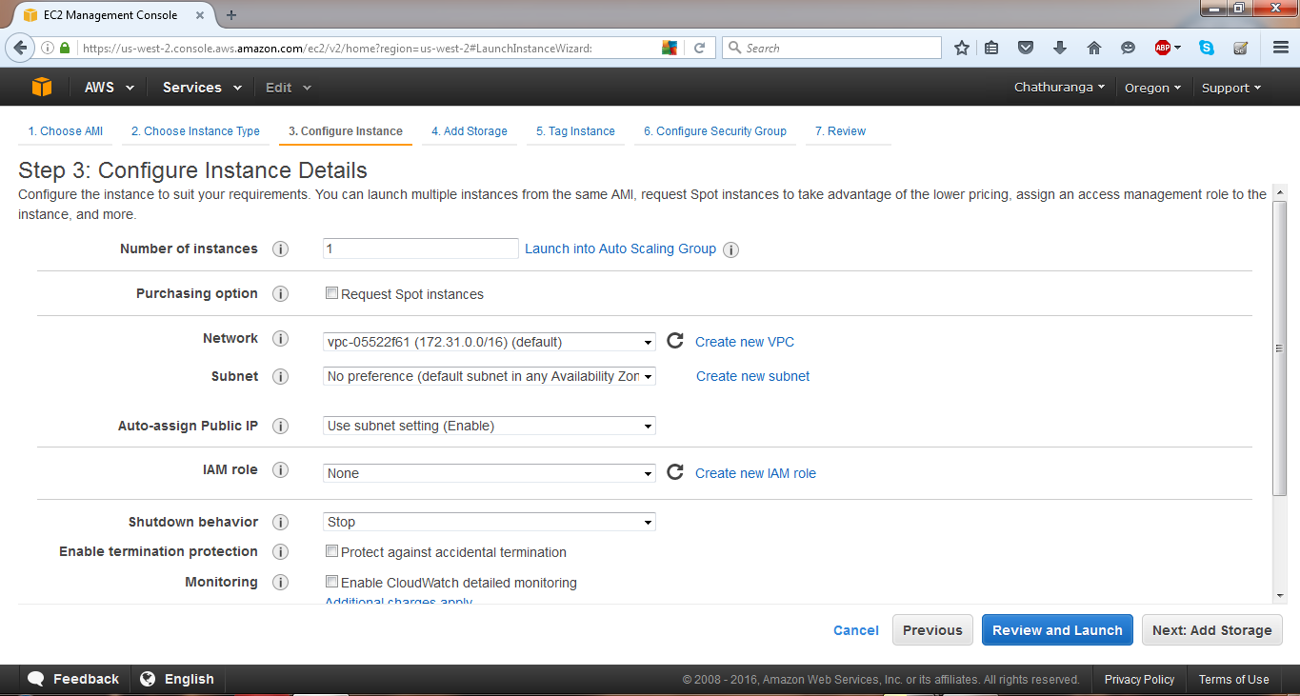

Select Next: Tag instance button.

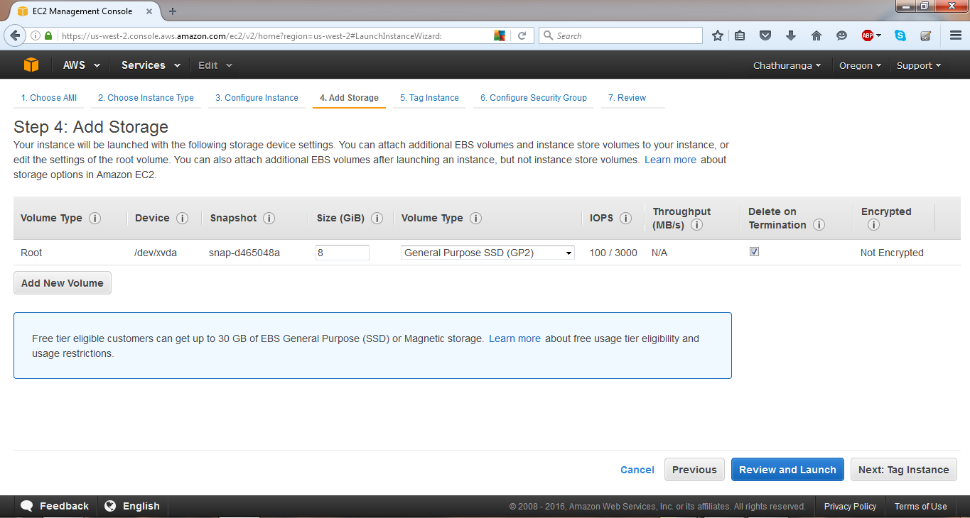

Click on the Review and Launch.

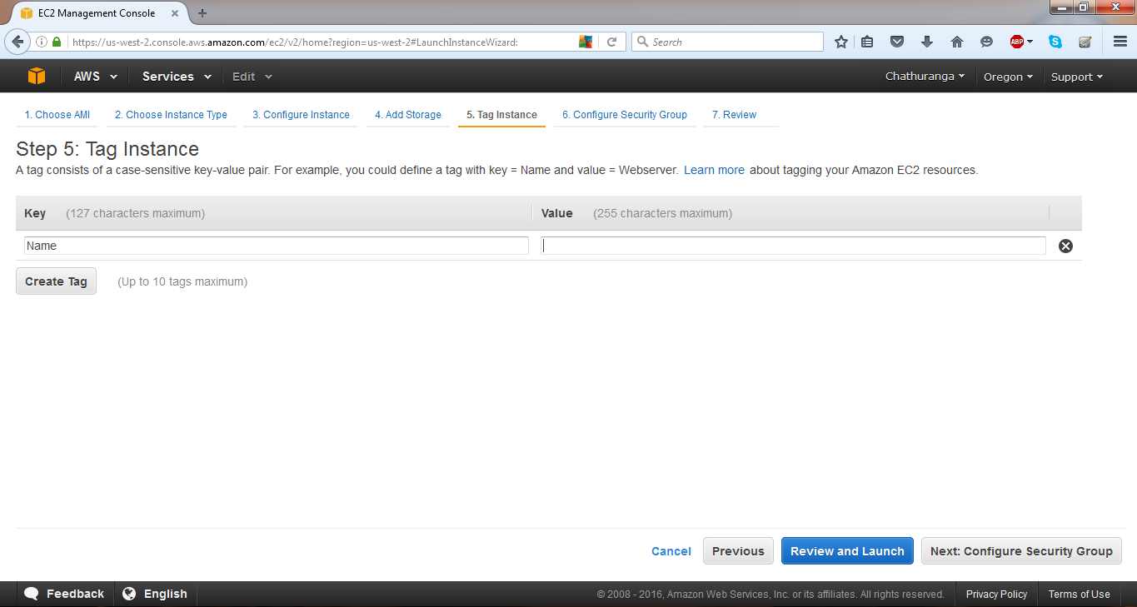

Click on the Launch button.

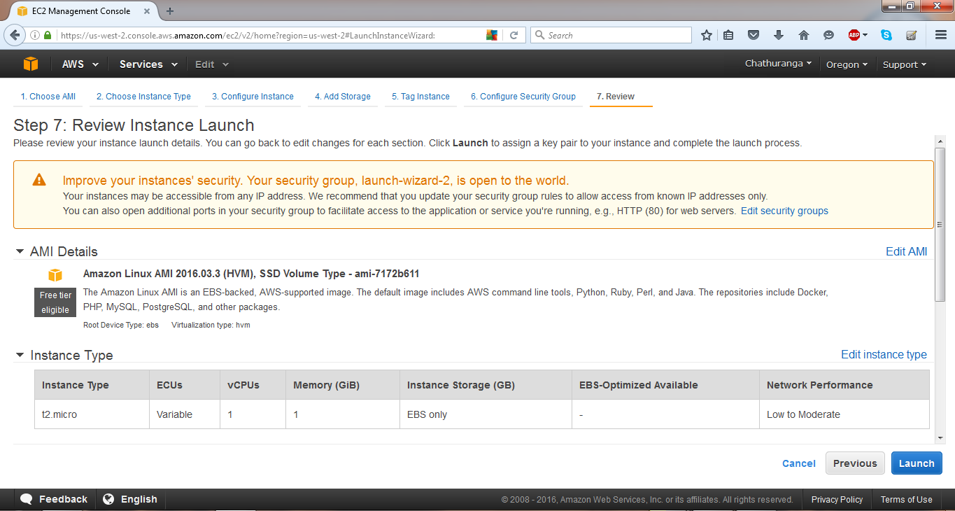

Create a new key pair and download the key pair. Then launch the instance.

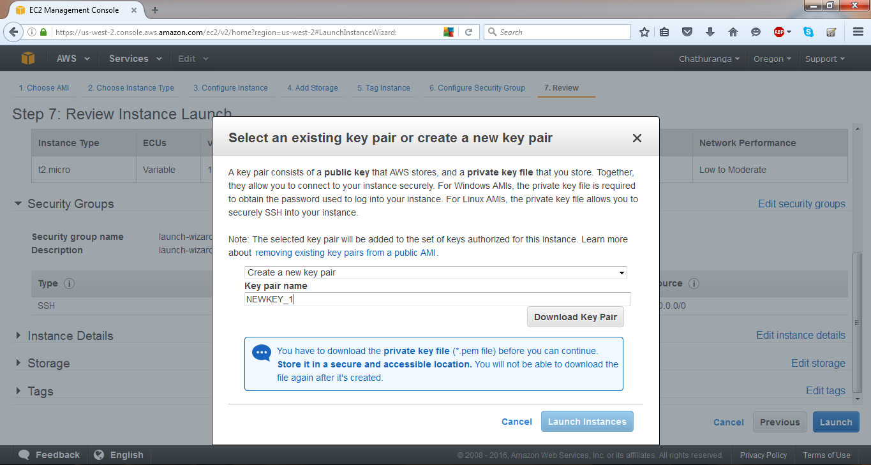

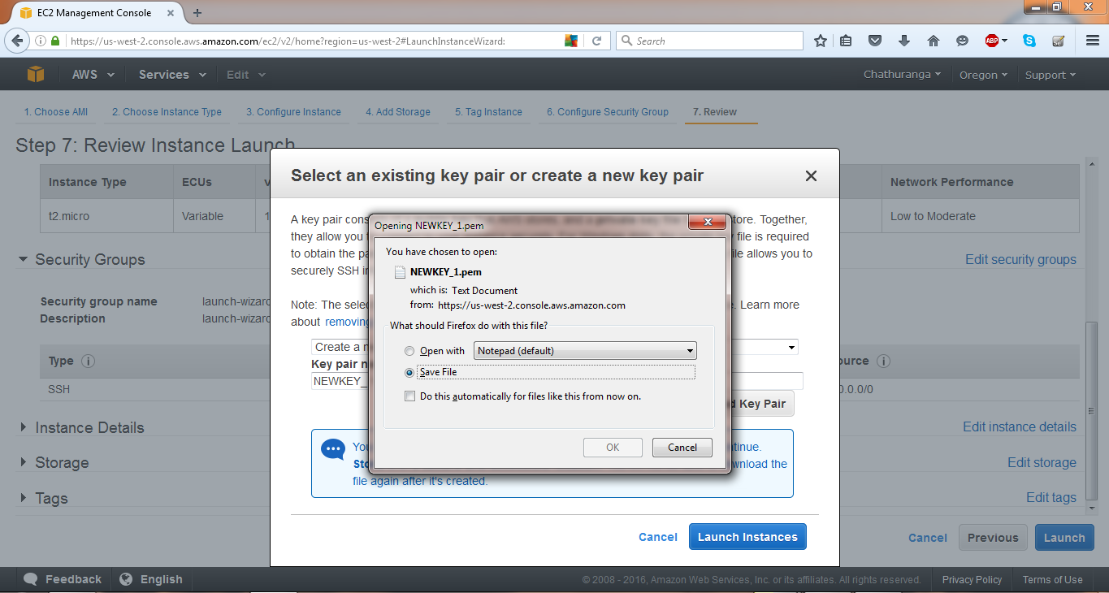

Then you will get Launch Status.

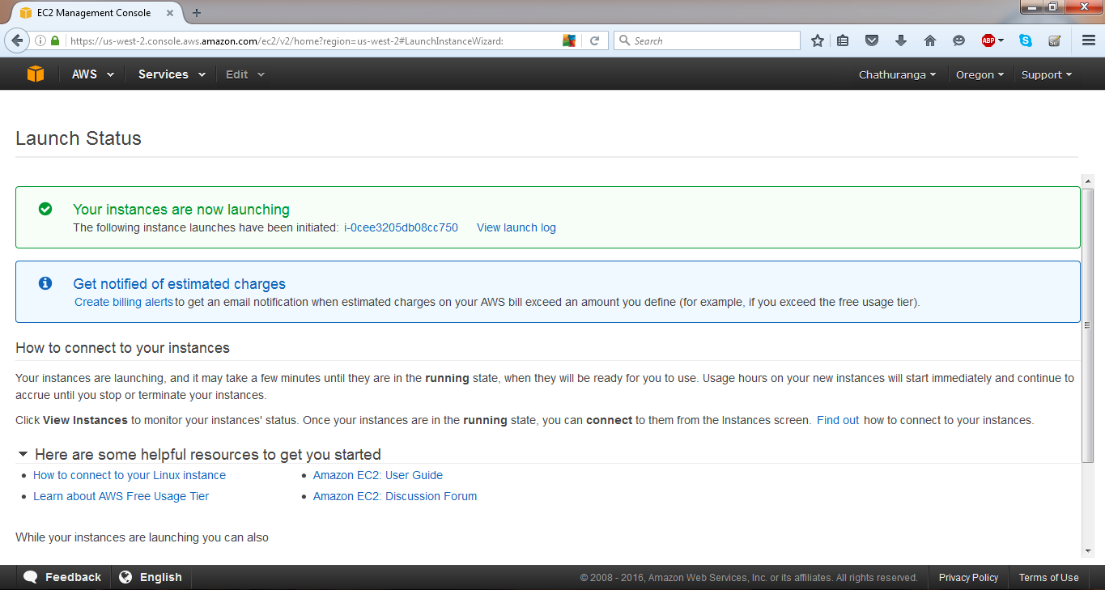

Then you will get the instance details.

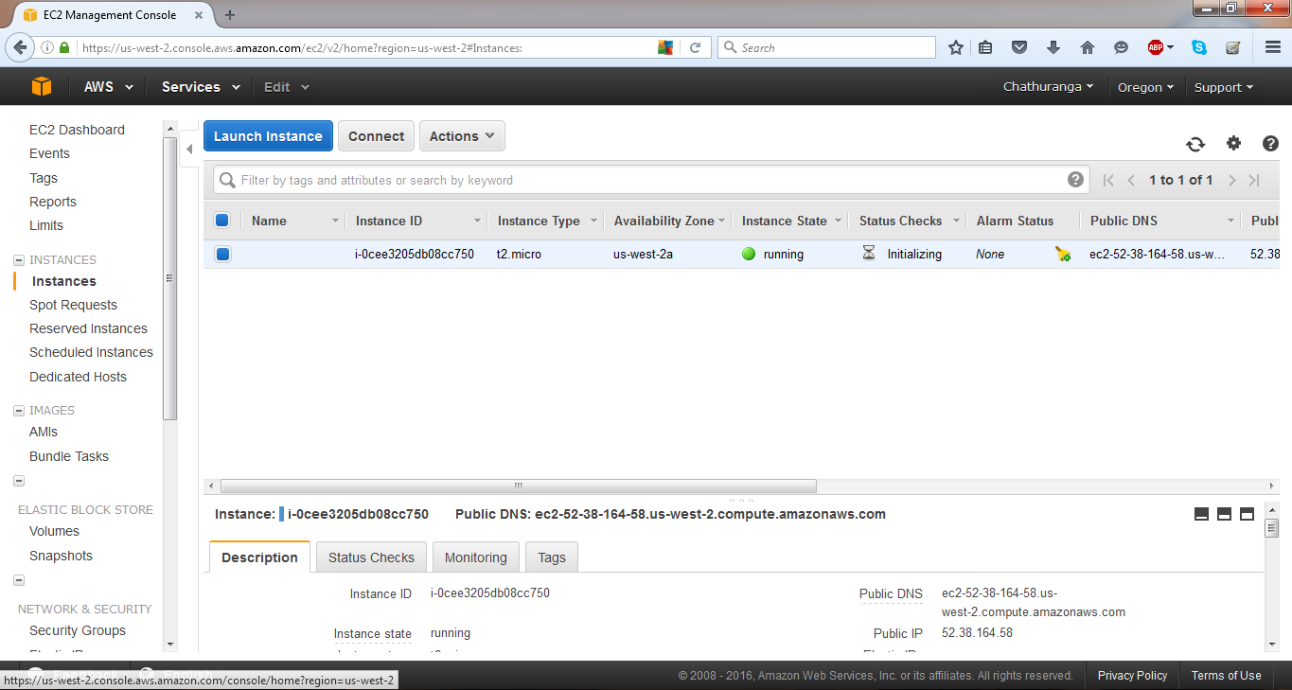

Download the PuTTY and PuTTY gen

Double click on the PuTTY gen. this dialog will appear. Generate the private key.

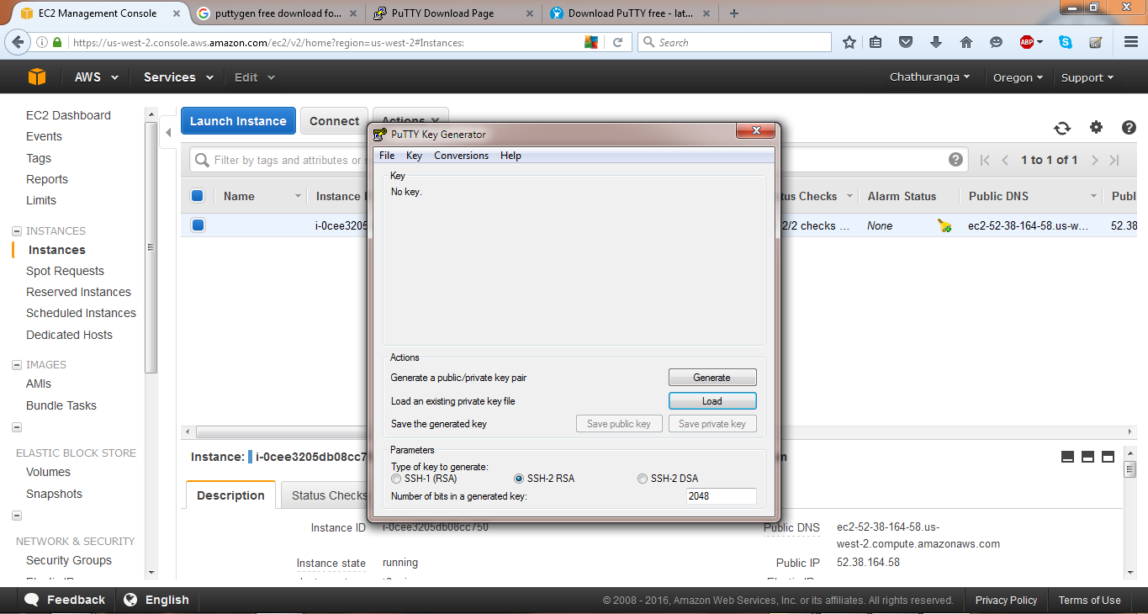

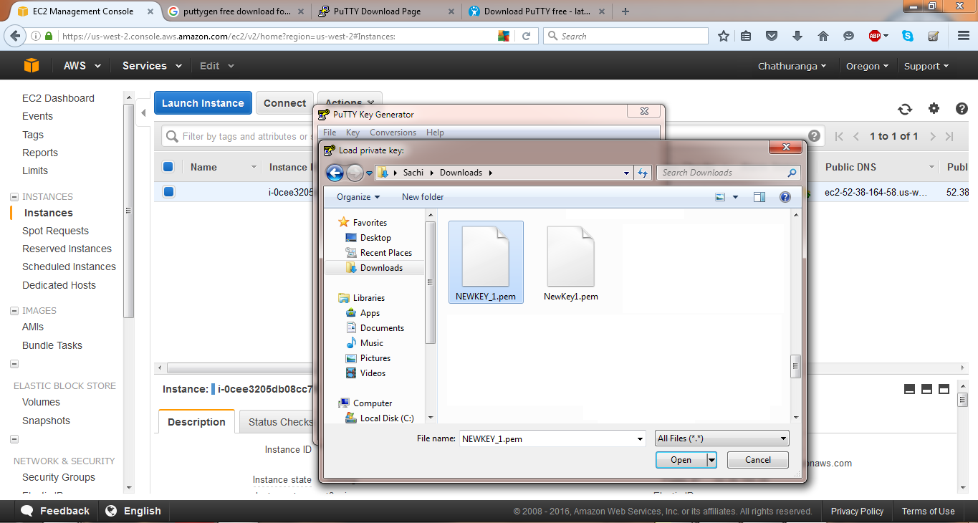

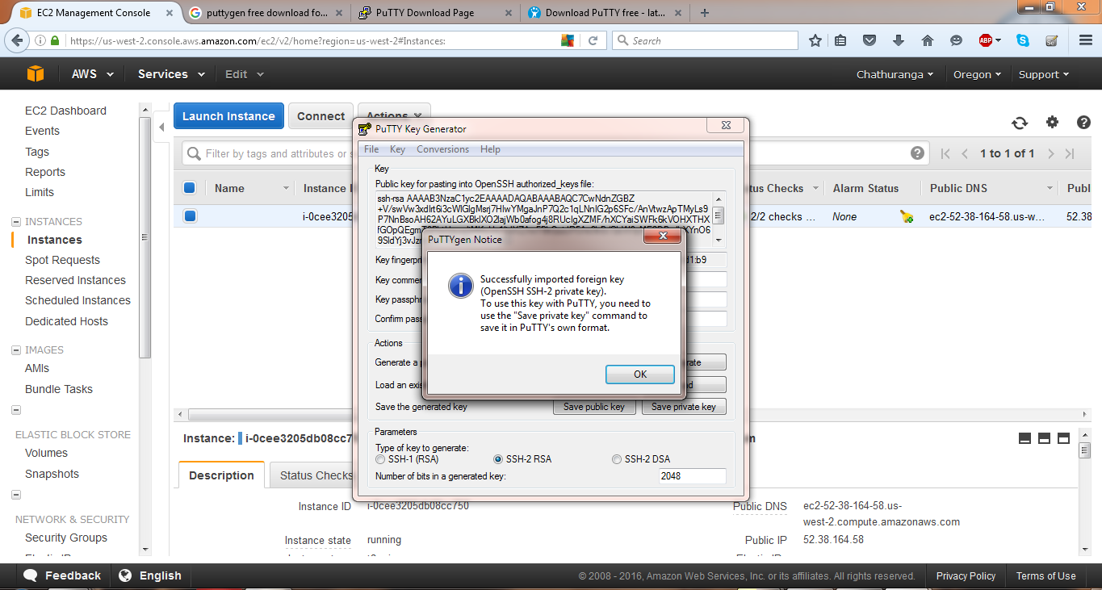

Load the private key.(.ppk)

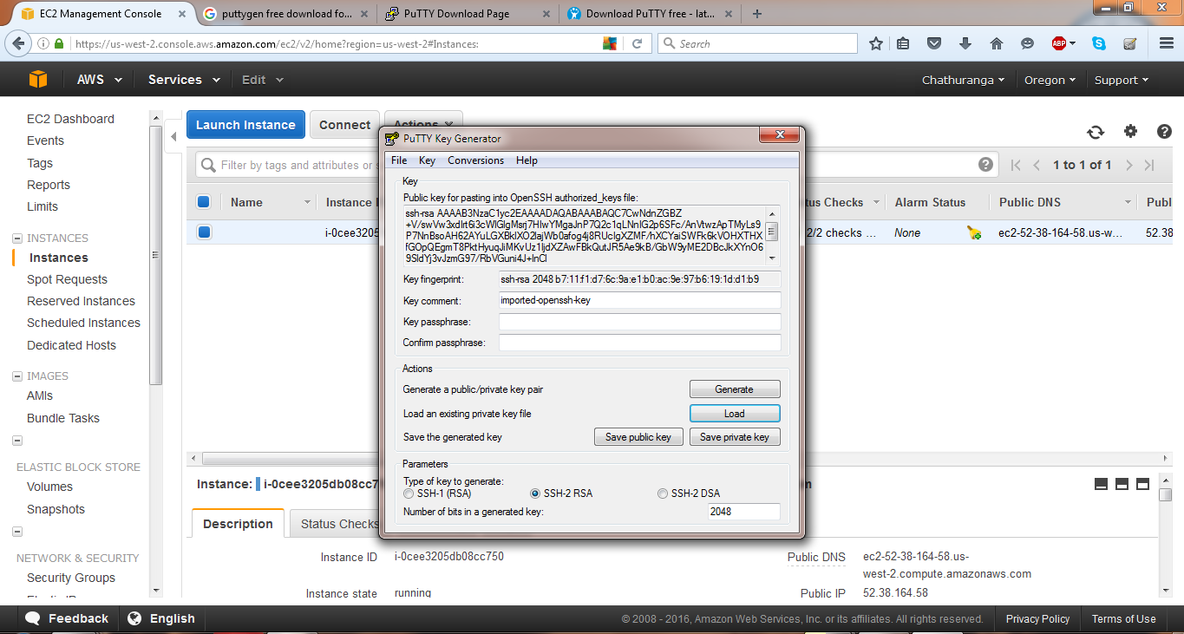

Then double click on the PuTTY configuration.

Give the public DNS as the host name. Then create a session and save it. (category🡪 session)

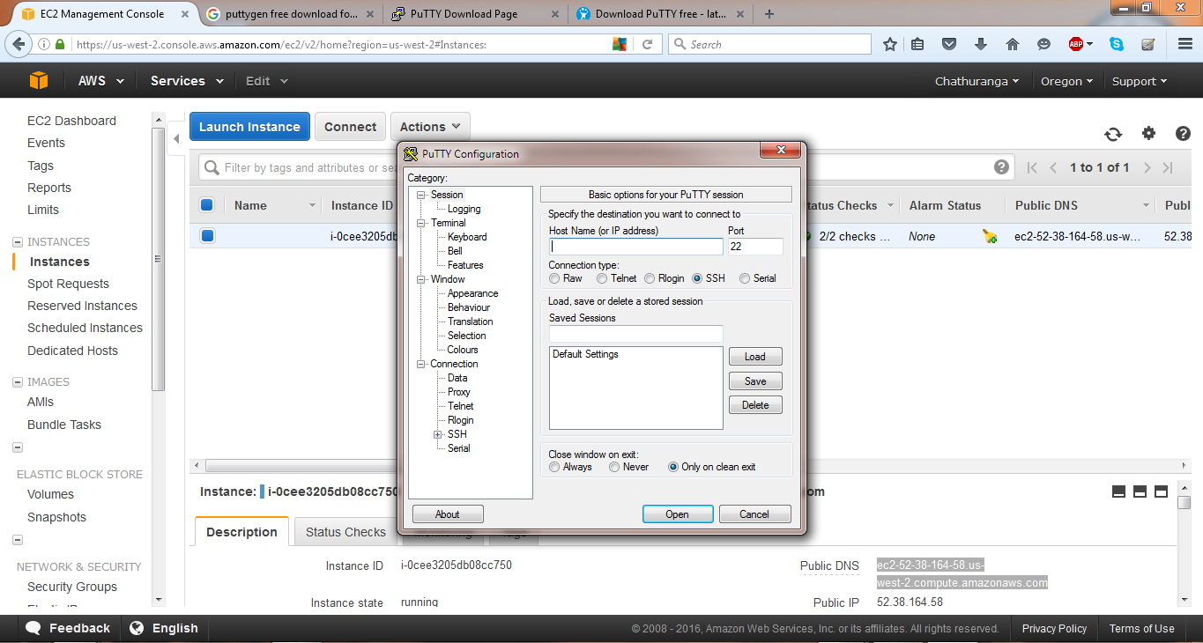

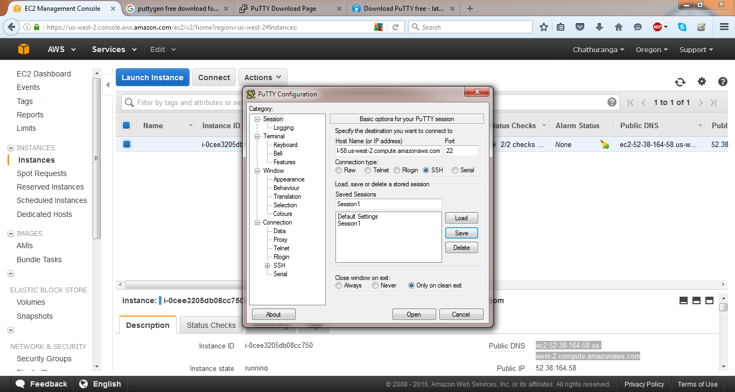

(category🡪 connection🡪 SSH 🡪 Auth)

Then open.

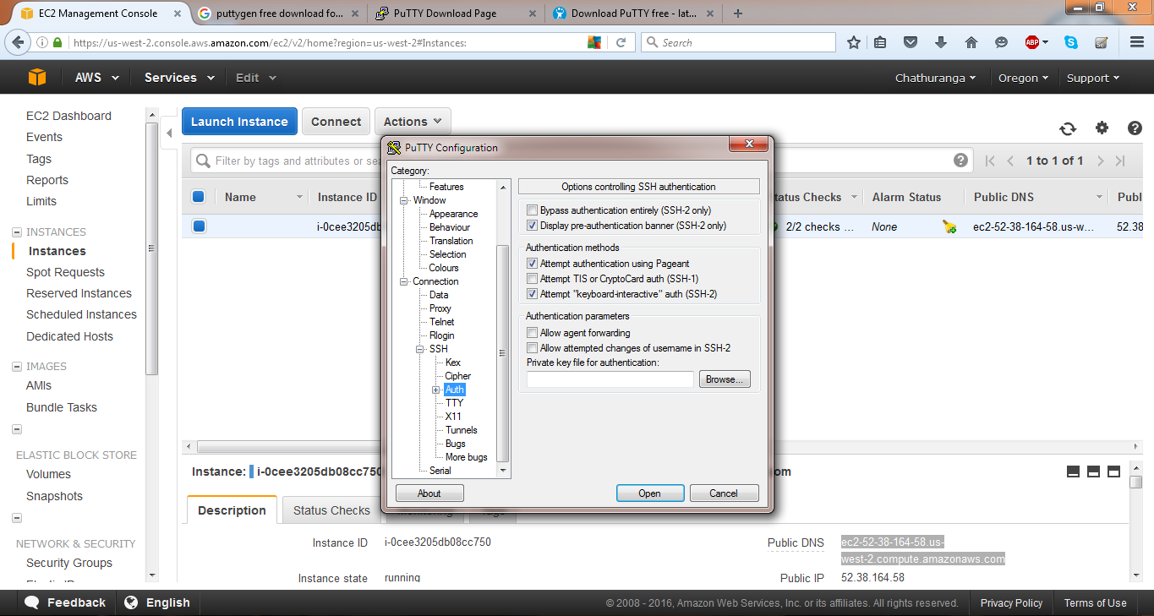

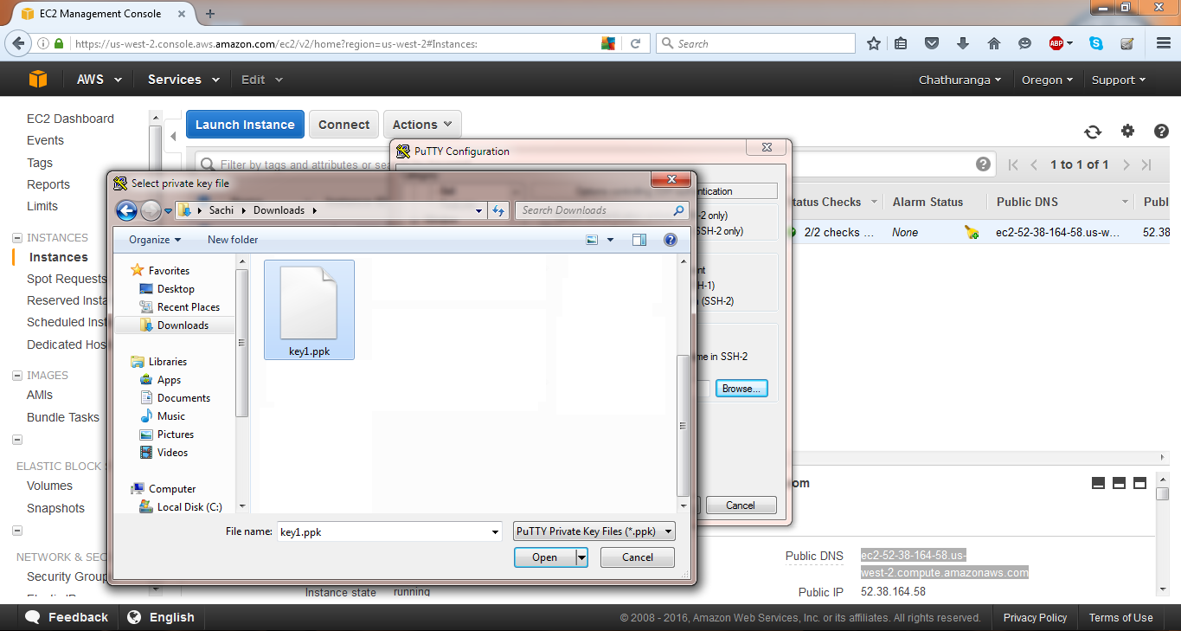

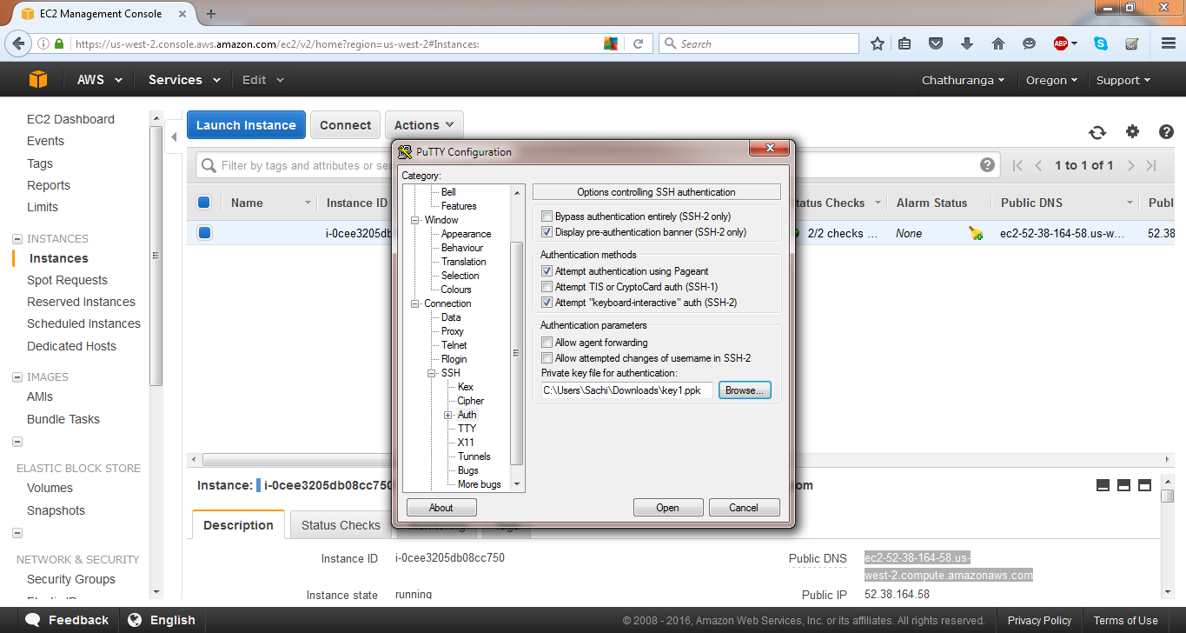

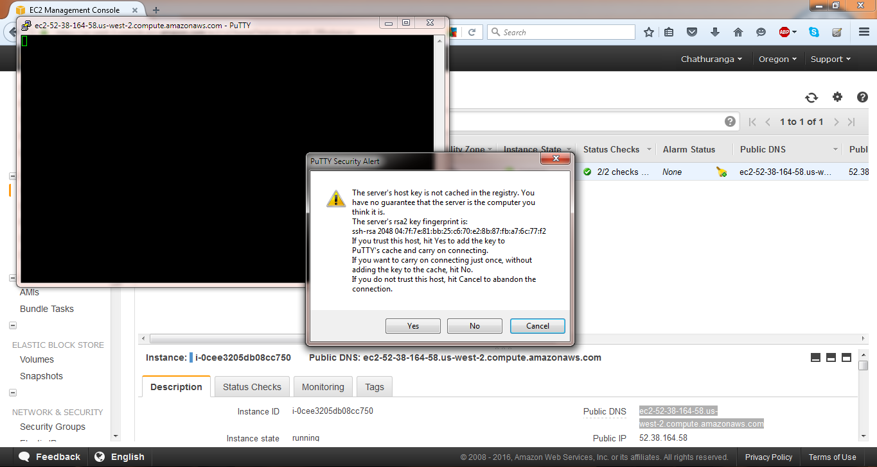

Type ec2-user to login.

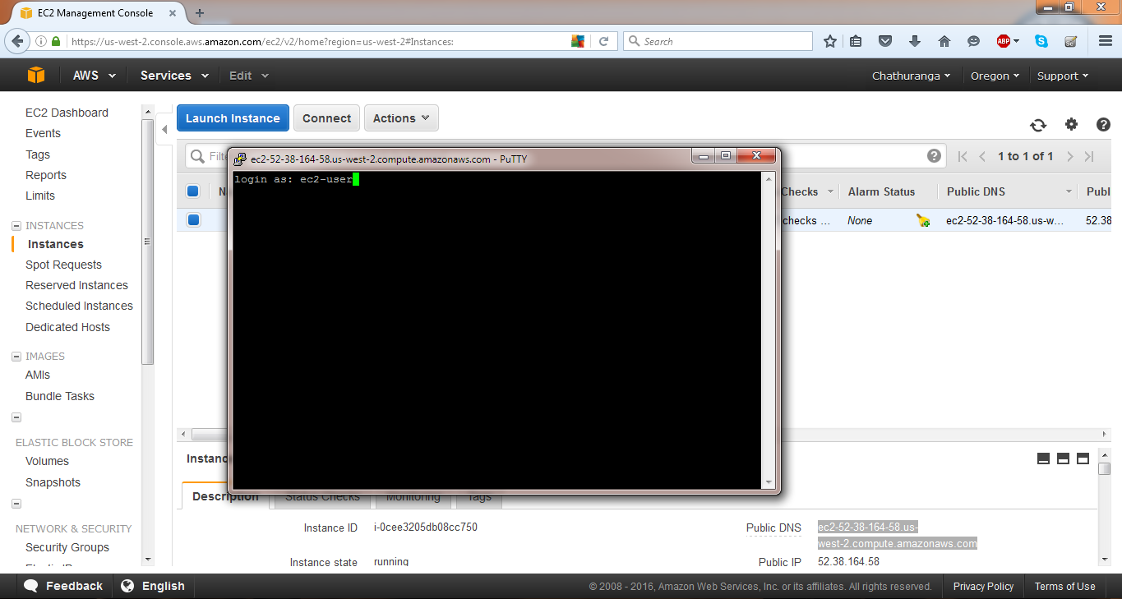

Then the Amazon Linux instance will appear.

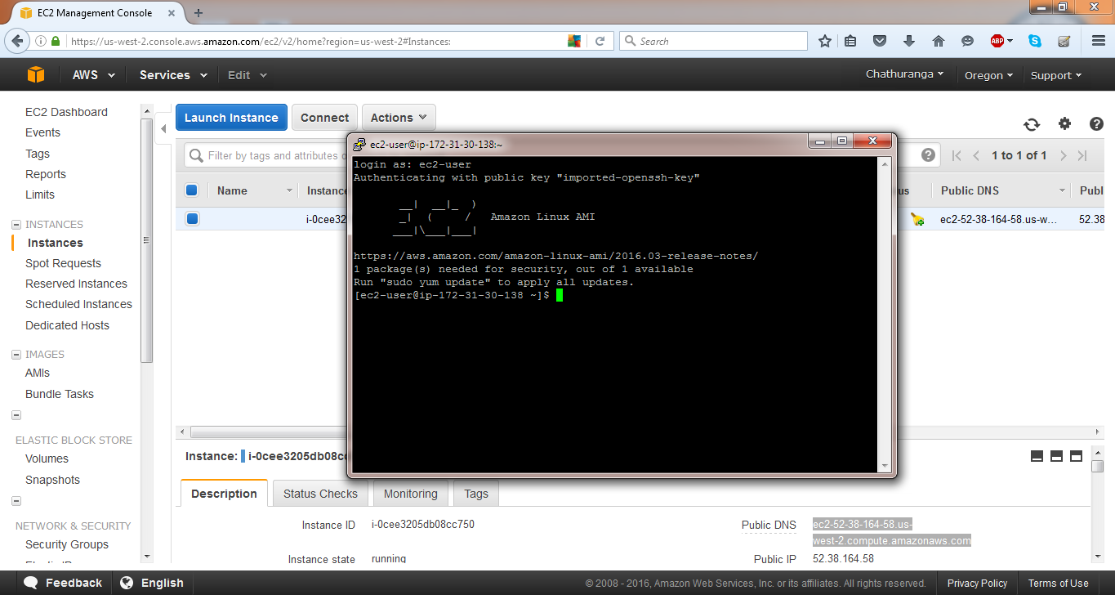

Getting started with Amazon RDS (Relational Database Service)

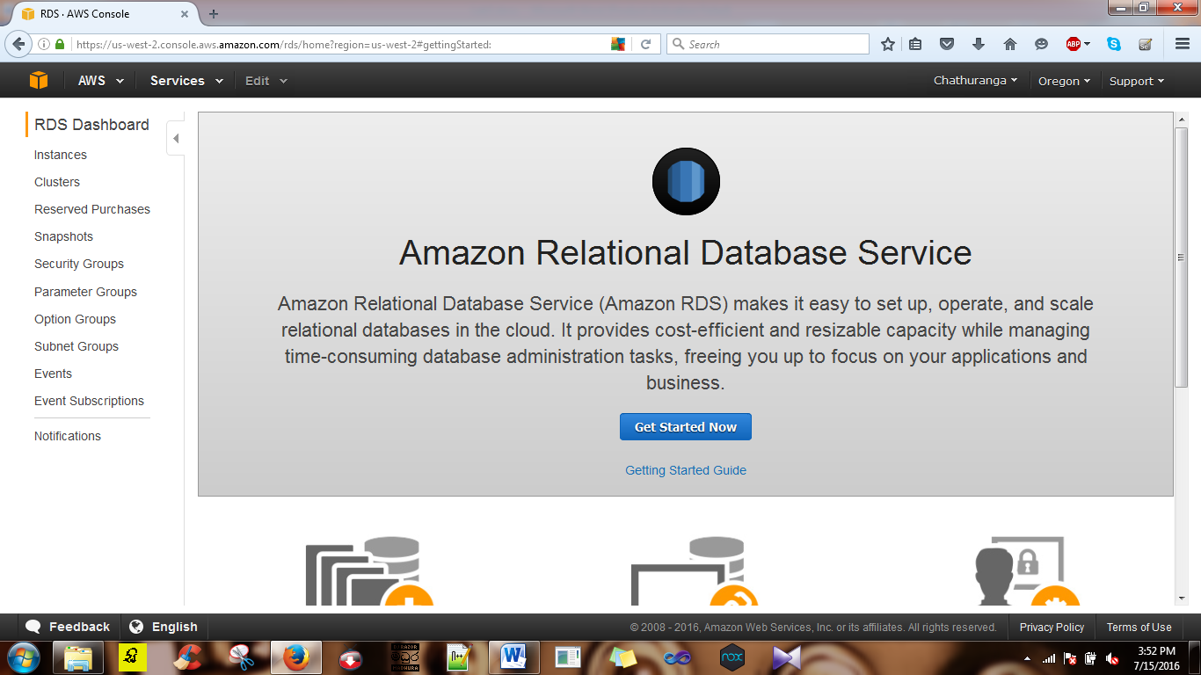

Create MySQL DB instance.

Go to services and select RDS. Then it is directed to the select engine page as this.

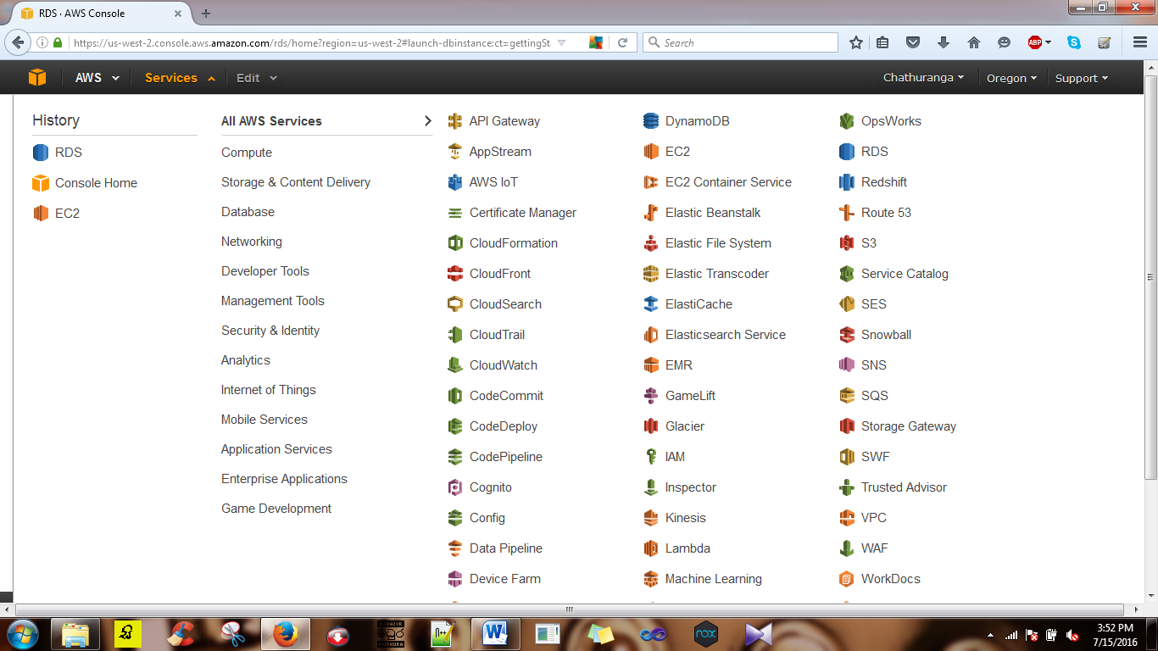

On the select engine page select MySQL, Then community edition.

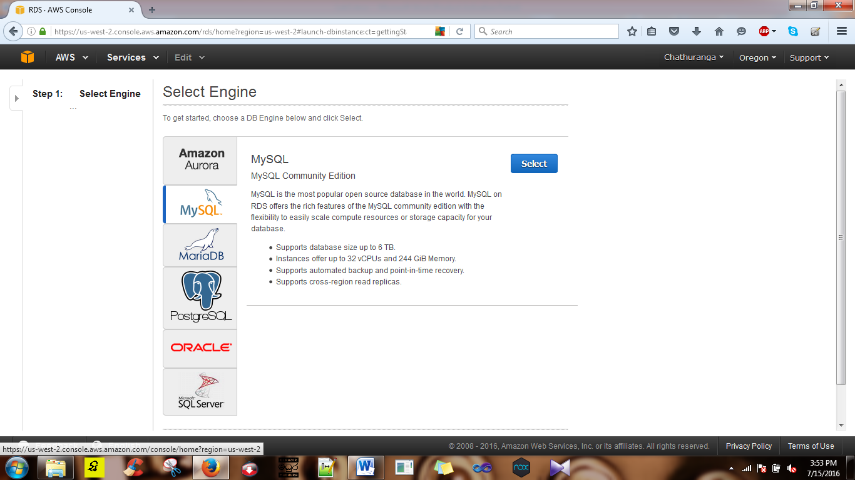

To select the production, tick on the MySQL and click on ‘next step’

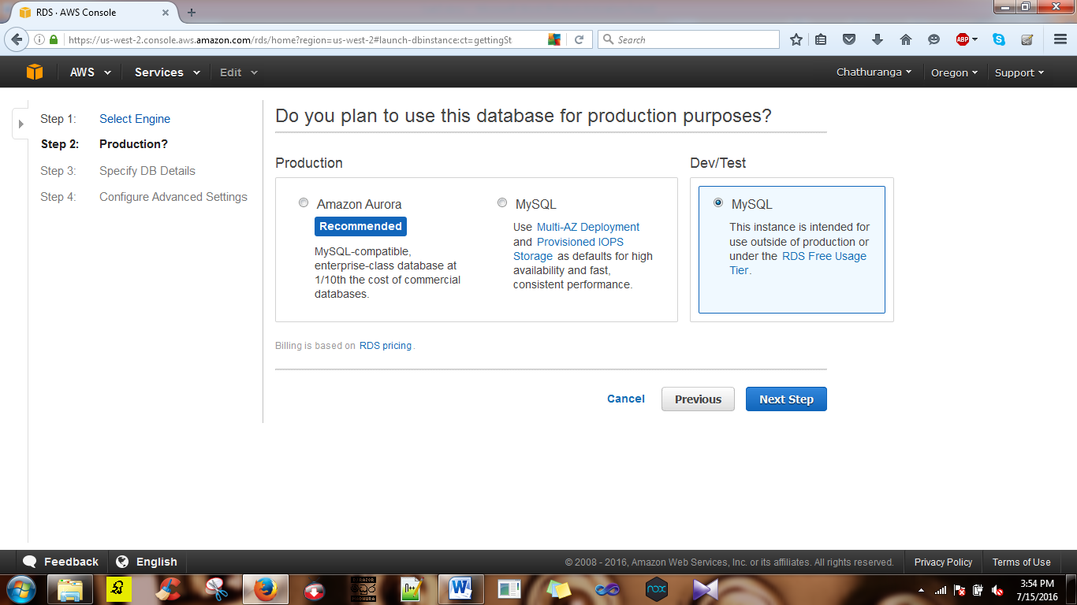

Then on the specify DB details page give the details as follow.

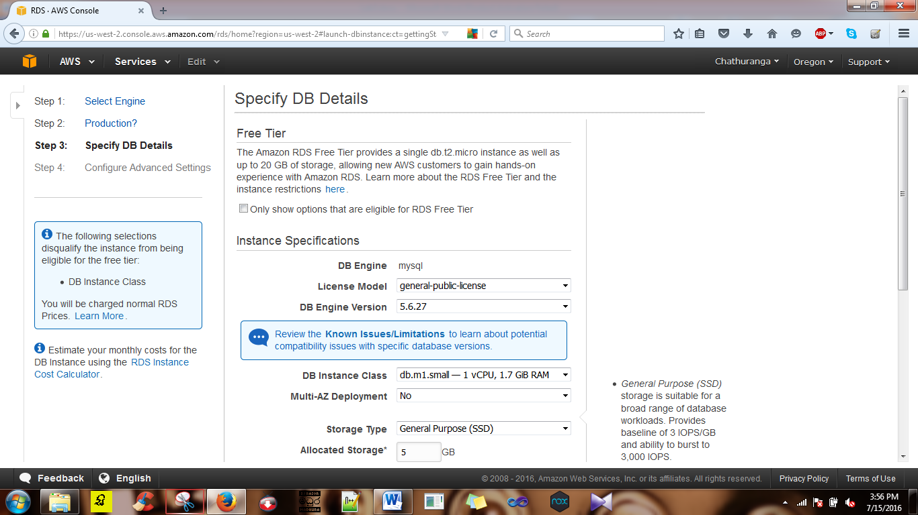

Give the username and password.

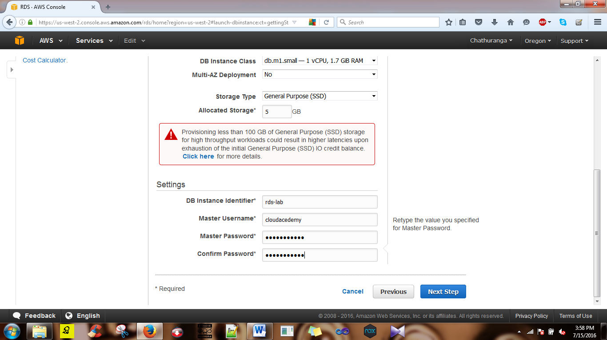

On the Configure Advanced Settings, given the additional information that need to launch the MySQL DB instance.

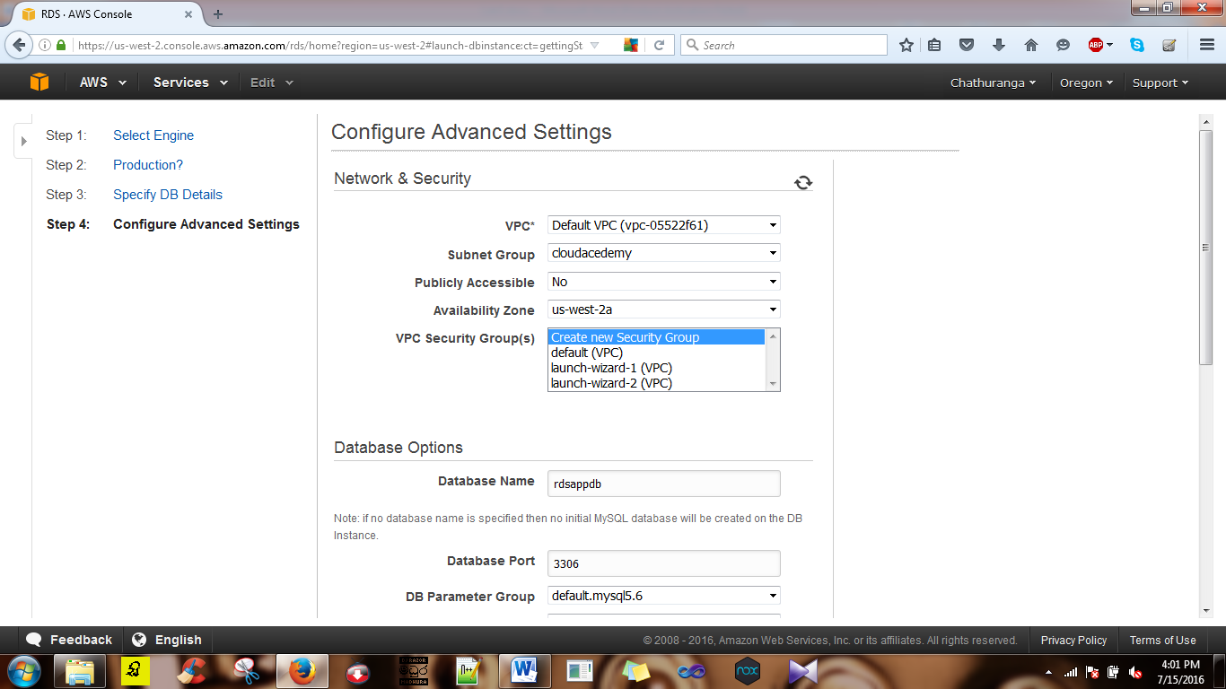

Steps to create the subnet group.

1. Go to subnet groups.
2. Then you get the interface to create the subnet group.
3. Give the name of the subnet group.
4. Click the add all the subnets button.
5. Then click the create button.

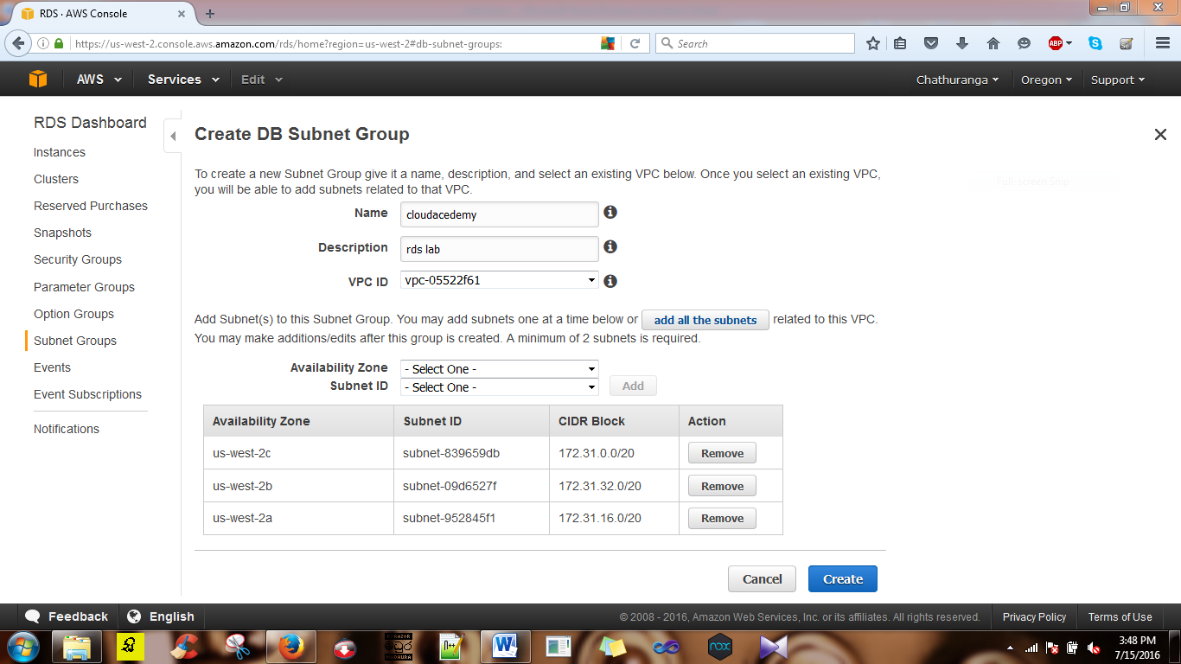

Go back to the Configure Advanced Settings and do these changes.

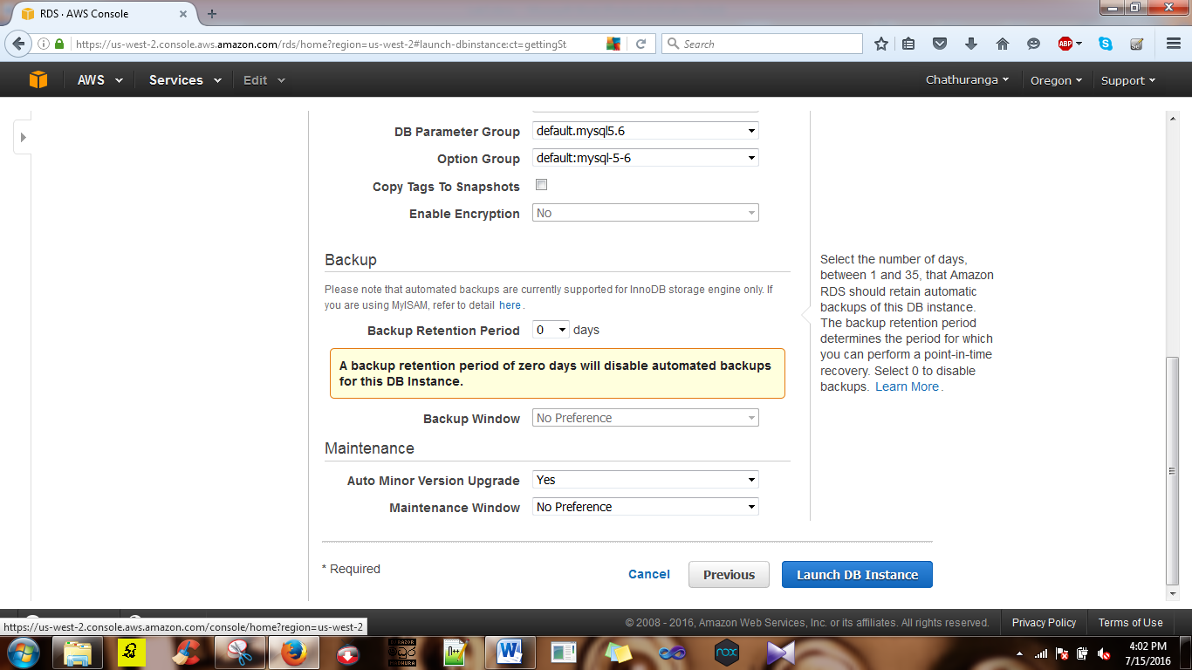

Then click on the Launch DB instance button.

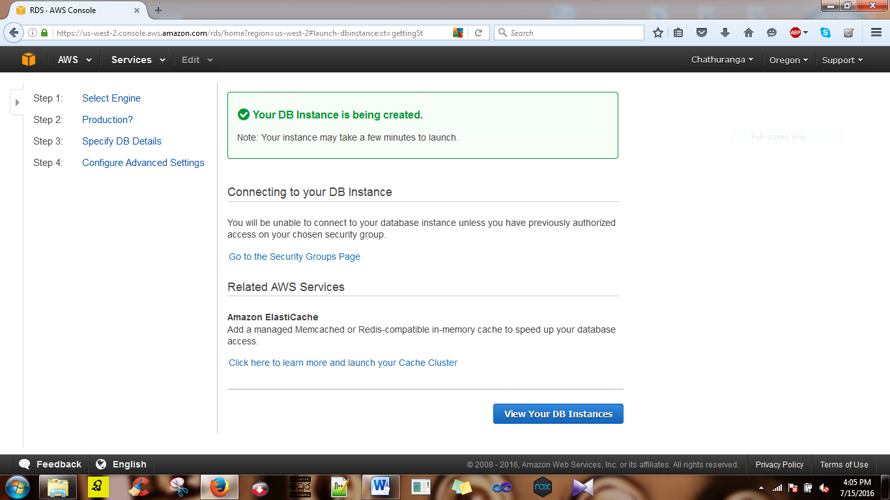

Then the DB instance is creating successfully.

